Case Study: Identifying Determinants of the Presence and Volume of Brown Fat in Human

Group 13: Lingfen Chen, Yayu Chen, Dhruv Goyal, Hyun Kim, Kenneth Kim

12/4/2021

### 1. Introduction

Brown adipose tissue (BAT), also commonly known as brown fat, is one of the two primary adipose tissues. The most common adipose tissue is white fat which accumulates through large lipid droplets regulating body temperature by providing insulation for the body's organs (Marcin, A. 2020). On the other hand, brown fat helps to regulate body temperature by generating body heat and burns excess energy (Fox, K., & Smith, B. 2018). Brown fat was thought to be only found in babies and small/hibernating mammals. Newborns have a lot of brown adipose tissue since they have not developed the shiver mechanic to create heat. The common consensus was that adults lose brown fat but develop the shiver mechanic to respond to cold body temperature. This occurs through a process called thermogenesis (Marcin, A. 2020). Thermogenesis is explained by the body producing a hormone in response to the temperature stimuli, and the receptors in the brown adipose tissue picking up the hormone and then begins to create heat and burn fat (Marcin, A. 2020). In the process, scientists believe that burning brown fat also burns calories. Thus, scientists and the medical community have postulated that the activation of brown fat could act as a possible therapeutic treatment for obesity and other metabolic diseases. Brown fat activation is linked with lower body weight, and better glucose and lipid regulation (Statistical Society of Canada, 2011). This is incredibly important because obesity is the fifth leading cause of deaths with an estimated 2.8 million adults each year (EASO, 2020) and 86.3% of adult Americans are projected to become obese by 2030(All Answers Ltd. , November 2018). It is imperative that we find possible treatments so that we can save people’s lives.

### 2. Objective

The objective of this analysis is to identify the factors determining the existence and the volume of brown fat in a large cohort of cancer patients. We aim to investigate the relationship between many explanatory variables and the presence of brown fat. From our analysis regarding the most significant covariates, we will attempt to build a model in order to estimate the probability of having brown fat.

### 3. Investigating the relationship between covariates

In order to complete our objective outlined earlier, the Molecular Imaging Center at The University of Sherbrooke provides cancer patient data. This data is classified as ungrouped data as it is not sorted into categories and grouped manners. In this data set, there is a response variable pertaining to the presence of brown fat and there are many covariate variables. Some of the variables in the data set include:   
 * Sex: sex of the patient (Female=1, Male=2).  
 * Diabetes: (No=0, Yes=1).  
 * Age: Age of the patient in years.  
 * Ext_Temp: External Temperature.  
 * Weight: in Kgs  
 * Size: in cms.  
 * BMI: Body Mass index.   
And more for a total of 23 variables, for 4842 patients.

## Exploration of the DataSet

We explore the dataset by taking a look at the number of male and female patients with brown fat and the corresponding average of brown fat volume in each gender:

## # A tibble: 2 x 2  
## Sex `n()`  
## <fct> <int>  
## 1 1 245  
## 2 2 83

## # A tibble: 2 x 2  
## Sex `mean(Total_vol)`  
## <fct> <dbl>  
## 1 1 46.1  
## 2 2 26.3

There is a presence of brown fat in 245 female and 83 male patients from the dataset. We observe that the presence of brown fat is 3 times more like in female patients than male. The female patients with presence of brown fat have a mean volume of 46.14 and the males have around 26. The female patients had greater brown volume fat than male.

## # A tibble: 2 x 2  
## Sex `n()`  
## * <fct> <int>  
## 1 1 2370  
## 2 2 2472

There were a total of 4,842 patients with 2,370 female patients and 2,472 male patients. The sample’s observed ratio of females having brown fat was 245 / 2,370 = 0.1033755 (10.34%) and males was 83 / 2,472 = 0.03357605 (3.36%).  
The probability of a female patient having brown fat was approximately 7% more likely than a male. Based on these results, we can focus on testing whether sex is a significant predictor of the prescense of brown fat. Since this data set is on cancer patients, we explore the data to see if different types of cancer can be a good predictor for the response variable.

BrownFatData %>%  
 ggplot(aes(x=Cancer_Type, y = Total_vol, color = BrownFat))+  
 ggtitle("Cancer Type on Total Volume of Brown Fat", ) + geom_boxplot()

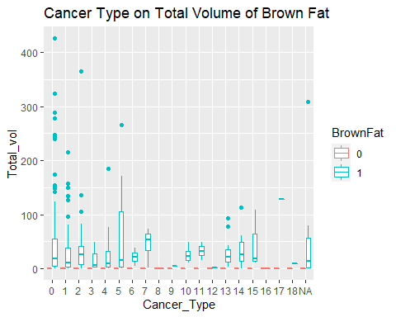 From this plot, we can see that some types of cancer may be a significant predictor for the presence of brown fat. We can also focus on cancer during the model selection process.

### Investigating the relationship between covariates

First we need to read in the dataset we will be working with, and take a look at the data.

## Id Sex Diabetes Age Day   
## Min. : 2 1:2370 0:4313 Min. : 0.04795 Min. : 3.0   
## 1st Qu.:2016 2:2472 1: 529 1st Qu.:54.19582 1st Qu.: 85.0   
## Median :3774 Median :63.17496 Median :178.0   
## Mean :3794 Mean :62.17426 Mean :178.1   
## 3rd Qu.:5635 3rd Qu.:71.95571 3rd Qu.:273.0   
## Max. :7652 Max. :94.09005 Max. :365.0   
##   
## Month Ext_Temp 2D_Temp 3D_Temp   
## Length:4842 Min. :-33.100 Min. :-24.200 Min. :-22.230   
## Class :character 1st Qu.: -2.900 1st Qu.: -4.350 1st Qu.: -4.600   
## Mode :character Median : 7.300 Median : 5.200 Median : 5.230   
## Mean : 6.248 Mean : 4.074 Mean : 4.052   
## 3rd Qu.: 16.800 3rd Qu.: 14.550 3rd Qu.: 14.470   
## Max. : 31.100 Max. : 24.250 Max. : 22.030   
##   
## 7D_Temp 1M_Temp Season Duration_Sunshine Weigth   
## Min. :-70.09 Min. :-13.996 1:1188 Min. :522.6 Min. : 9.14   
## 1st Qu.: -5.94 1st Qu.: -7.170 2:1148 1st Qu.:597.6 1st Qu.: 60.50   
## Median : 5.63 Median : 5.730 3:1267 Median :724.8 Median : 71.00   
## Mean : 3.94 Mean : 4.202 4:1239 Mean :729.2 Mean : 73.21   
## 3rd Qu.: 14.49 3rd Qu.: 13.910 3rd Qu.:862.2 3rd Qu.: 83.00   
## Max. : 20.61 Max. : 18.650 Max. :940.2 Max. :202.00   
##   
## Size BMI Glycemy LBW   
## Min. : 78.3 Min. :12.39 Min. : 2.900 Min. : 7.763   
## 1st Qu.:158.0 1st Qu.:22.70 1st Qu.: 5.200 1st Qu.:43.758   
## Median :165.0 Median :25.79 Median : 5.600 Median :50.089   
## Mean :165.5 Mean :26.63 Mean : 5.859 Mean :51.546   
## 3rd Qu.:172.0 3rd Qu.:29.64 3rd Qu.: 6.200 3rd Qu.:58.987   
## Max. :194.0 Max. :69.80 Max. :67.000 Max. :84.926   
##   
## Cancer_Status Cancer_Type TSH BrownFat Total_vol   
## 0 :1947 0 :1947 Min. : 0.010 0:4514 Min. : 0.000   
## 1 :2645 1 :1010 1st Qu.: 0.970 1: 328 1st Qu.: 0.000   
## NA's: 250 2 : 467 Median : 1.720 Median : 0.000   
## 13 : 302 Mean : 2.873 Mean : 2.786   
## 5 : 178 3rd Qu.: 2.830 3rd Qu.: 0.000   
## (Other): 569 Max. :96.700 Max. :426.030   
## NA's : 369 NA's :4425

From the summary above, we know that There are “NA” Values, we need to remove or replace the NA with Mode

Count_NA = vector()  
for (i in (1:dim(BrownFatData)[2])) {  
 temp = BrownFatData[,i]  
 Count_NA = c(Count_NA, sum(is.na(temp)))  
}  
Output = cbind(colnames(BrownFatData), Count_NA)  
print(Output)

## Count_NA  
## [1,] "Id" "0"   
## [2,] "Sex" "0"   
## [3,] "Diabetes" "0"   
## [4,] "Age" "0"   
## [5,] "Day" "0"   
## [6,] "Month" "0"   
## [7,] "Ext_Temp" "0"   
## [8,] "2D_Temp" "0"   
## [9,] "3D_Temp" "0"   
## [10,] "7D_Temp" "0"   
## [11,] "1M_Temp" "0"   
## [12,] "Season" "0"   
## [13,] "Duration_Sunshine" "0"   
## [14,] "Weigth" "0"   
## [15,] "Size" "0"   
## [16,] "BMI" "0"   
## [17,] "Glycemy" "0"   
## [18,] "LBW" "0"   
## [19,] "Cancer_Status" "250"   
## [20,] "Cancer_Type" "369"   
## [21,] "TSH" "4425"   
## [22,] "BrownFat" "0"   
## [23,] "Total_vol" "0"

From the summary we observed NA values in the column “Cancer_Status”, “Cancer_Type”, “TSH”. The NA values could represent patients who have not been tested. In the “TSH” column, there are 4,425 patients with NA values out of 4,842 patients (More than 90% of total patients) which means there is not enough information about “TSH” to test the relationship between other factors. Other research shows patients with BAT will tend to have higher TSH level(thyroid-stimulating hormone).(Lapa C, et al. 2015). The data set records TSH, but we chose not to include TSH in the model. Since 90% of TSH are missing, we thus made the decision to remove the “TSH” level.

To adjust NA values for “Cancer_Status” and “Cancer_Type”, it is appropriate to exclude the NA values of “Cancer_Status” and “Cancer_Type” as well to study the relationship between each factor as we still have enough information to analyze the relationship. Removing 250 NA values would represent only about 5.1% of the values, and R also uses na.omit and na.exclude to deal with NA values. This process removes the data of the patients who only have NA values for either “Cancer_Status” or “Cancer_Type”.

We can also look at possible effects of multicollinearity whether the variables with NA are highly correlated with another variable, we can drop the variables with NA values. Interpolation is another possible solution, however since in the TSH column we only have a limited amount of values (approx. 9%), we believe that interpolation can possibly lead to over/under stating the effect on the response variables and thus produce inaccurate results.

We take a look at the variance covariance matrix to identify possible multicollinearity between variables. We plot the matrix for quantitative predictors:

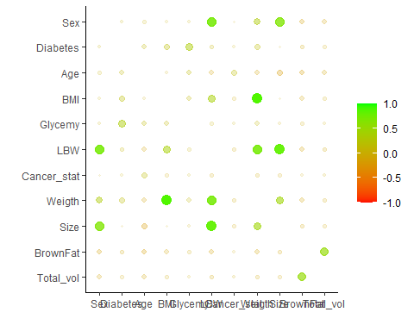 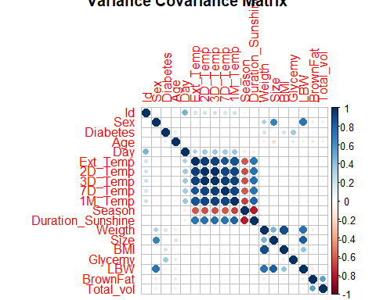

We can see from the variance covariance matrices, that there is a strong correlation between Weight and BMI, Sex and Size, Sex and Lean Body Weight, Size and LBW, Size and Weight. We can also see that the presence of Brown Fat and Total Brown Fat volume are correlated. There is a strong correlation between the External temperature and all other temperature measurements, and with the Duration of Sunshine.

We then take a look at the categorical predictors and we plot the correlation of Categorical variables with BrownFat:

From these matrices, we can see that we do not need to examine all the covariates against the response variable, as examining one of the correlated predictors, we would see similar effects due to the principles of multicollinearity.

After removing variable “TSH”, we investigate which variables have significant effects on having brown fat. Since this model contains many variables, we observed there are some correlations between variables. For example, as identified earlier, size and weight, exemplifies multicollinearity.

plot(BrownFatData$Size,BrownFatData$Weigth, main = "Correlation of Size and Weigth")

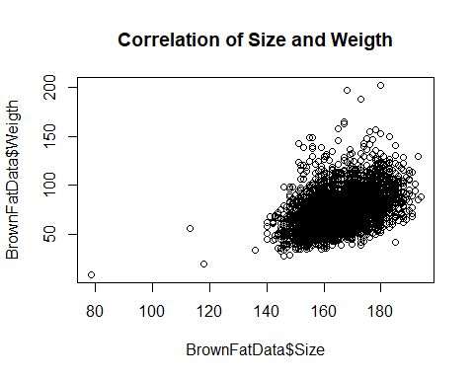 Based on our introduction we explore the most significant factor for the presence of brown fat which is low air temperature. This is because brown fat needs to be activated by a low ambient temperature to be detected. We then plot the external temperature against the response variable brown fat:

Brown_Fat = as.character(BrownFatData$BrownFat)  
p1 = ggplot(BrownFatData, aes(x = Brown_Fat, y = Ext_Temp,color=BrownFat))+geom_boxplot() + ggtitle("The effect of Ext_Temp on Brown_Fat") + xlab("Brown_Fat") + ylab("Ext_Temp")  
p1

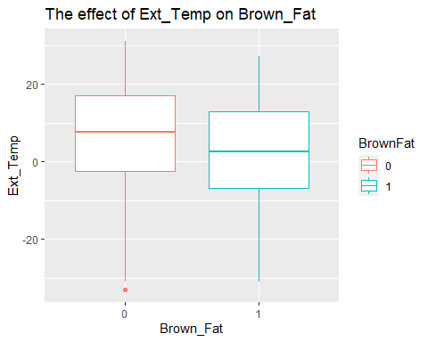

With this boxplot we look at the effects of external temperature on patients with and without brown fat. It is shown that external temperature among patients with brown fat have lower external temperatures on average. We can also see that there is an outlier in external temperature for patients without brown fat. The mean external temperatures for the existence of brown fat is lower than the mean temperature for non-brown fat. However, there are large variabilities for both groups, evident by the long whiskers.

We then explore the relationship between external temperature and the total volume of brown fat:

p2 = ggplot(BrownFatData,aes(x = Ext_Temp, y=Total_vol, color=BrownFat))+geom_point() + ggtitle("The effect of Ext_Temp on Total_Vol_Brown_Fat") + xlab("Ext_Temp") + ylab("Total_Vol_Brown_Fat")  
p2

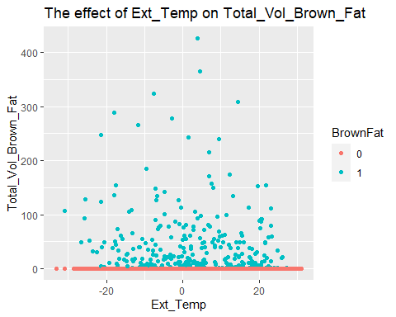

From this scatter plot, we can see that the patients without brown fat have 0 volume of brown fat. The effect of external temperature on total volume of brown fat looks random which means the increase/decrease of the external temperature does not have a significant effect on total volume of brown fat. Therefore, the relationship between external temperature and the total volume of brown fat may be independent, despite us identifying correlation between total brown fat volume and the presence of brown fat. This tells us that there may be other important predictors which will affect the presence and volume of brown fat.

Taking a look at the plot between other temperature measurements, 2D_Temp and 3D_Temp we can see that the plots look very similar which would confirm the multicollinearity effect that we observed in the matrix.

plot(BrownFatData$'2D_Temp',BrownFatData$Total_vol,xlab ='2D_Temp',ylab='BrownFat Vol', main="2D Temperature vs Brown Fat Vol")

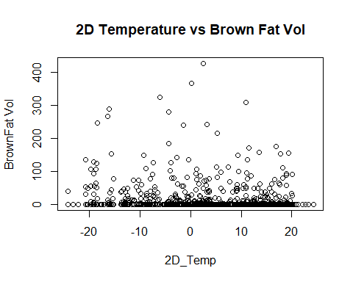

plot(BrownFatData$'3D_Temp',BrownFatData$Total_vol,xlab ='3D_Temp',ylab='BrownFat Vol', main="3D Temperature vs Brown Fat Vol")

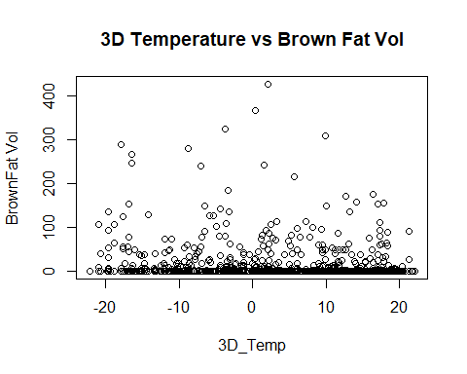

So we can say with some confidence that Ext_Temp, 2D_Temp, 3D_Temp, 7D_Temp, 1M_Temp, Season, Duration_Of_Sunshine are correlated together and have a significant relationship with the presence of brown fat.

We can also see that from our correlation matrix that the Weight and BMI are correlated We plotted the effect of BMI and weight on the presence of brown fat and the similar result of both plots represent multicollinearity.

plot(BrownFatData$Weigth,BrownFatData$Total_vol,xlab ='Weight',ylab='BrownFat Vol', main="Weight vs Brown Fat Vol")

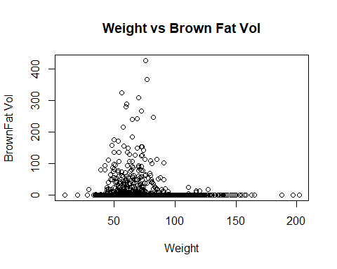

plot(BrownFatData$BMI,BrownFatData$Total_vol,xlab ='BMI',ylab='BrownFat Vol', main="BMI vs Brown Fat Vol")

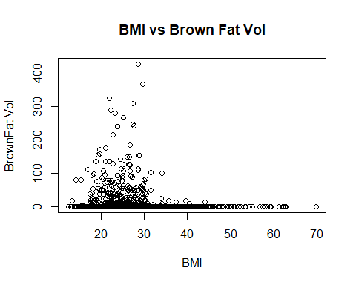 From these plots, we see that patients with high brown fat volume are on the lower range of both weight and BMI, and these two variables could be a significant predictor. Thus the other highly correlated variables might also have a significant effect on brown fat due to multicollinearity.

In order to deal with the possible identified multicollinearity we could drop one of the variables that is correlated less with the response variable or during the model selection process, see if the correlated variables become insignificant and then drop out.

We aim to use a stepwise regression model selection process first, then see if any of the remaining significant predictors are highly correlated. From there we can use VIF or fit multiple models, to see which predictors are the most significant in fitting the data.

### 5. Building Model for Prediction

To study the effect of explanatory variables against the response variable brown fat, we fit the model using logistic regression method as the response variable is a binary variable which only has 2 outcomes of having / not having a brown fat.

We first fit:

fat <- read_excel("D:/STAC51/Group Study/BrownFat.xls")  
attach(fat)  
#set the generalized model:  
#categorize all variables contain positive integers.  
Brownfat = as.numeric(BrownFat == 1)  
Male = as.numeric(Sex == 2)  
Diabetes = as.numeric(Diabetes == 1)  
Summer = as.numeric(Season == 2)  
Autumn = as.numeric(Season == 3)  
Winter = as.numeric(Season == 4)  
r_Duration_Sunshine = Duration_Sunshine - 529.2  
Cancer = as.numeric(Cancer_Status == 1)  
Two_Day_Temp = fat$'2D_Temp'  
Three_Day_Temp = fat$'3D_Temp'  
Seven_Day_Temp = fat$'7D_Temp'  
One_Month_Temp = fat$'1M_Temp'  
#Drop TSH  
model = glm(BrownFat~Male+Diabetes+Age+Day+Month+Ext_Temp+Two_Day_Temp+  
Three_Day_Temp+Seven_Day_Temp+One_Month_Temp+Summer+Autumn+Winter+  
r_Duration_Sunshine+Weigth+Size+BMI+Glycemy+LBW+Cancer+  
Cancer_Type,family =binomial(link = 'logit'),data=fat)  
summary(model)

##   
## Call:  
## glm(formula = BrownFat ~ Male + Diabetes + Age + Day + Month +   
## Ext_Temp + Two_Day_Temp + Three_Day_Temp + Seven_Day_Temp +   
## One_Month_Temp + Summer + Autumn + Winter + r_Duration_Sunshine +   
## Weigth + Size + BMI + Glycemy + LBW + Cancer + Cancer_Type,   
## family = binomial(link = "logit"), data = fat)  
##   
## Deviance Residuals:   
## Min 1Q Median 3Q Max   
## -1.3328 -0.4022 -0.2659 -0.1693 3.1065   
##   
## Coefficients:  
## Estimate Std. Error z value Pr(>|z|)   
## (Intercept) -2.776105 4.708641 -0.590 0.555474   
## Male -1.360414 0.236205 -5.759 8.44e-09 ***  
## Diabetes -1.505254 0.431635 -3.487 0.000488 ***  
## Age -0.038052 0.004509 -8.438 < 2e-16 ***  
## Day -0.003750 0.007072 -0.530 0.595924   
## MonthAugust -0.503049 1.178006 -0.427 0.669354   
## MonthDecember 1.397134 2.148992 0.650 0.515605   
## MonthFebruary 0.490808 1.053285 0.466 0.641231   
## MonthJanuary 0.259339 1.142788 0.227 0.820474   
## MonthJuly -0.203113 1.089901 -0.186 0.852163   
## MonthJune 0.165188 0.881385 0.187 0.851332   
## MonthMarch 0.636067 0.642290 0.990 0.322022   
## MonthMay 0.077397 0.515423 0.150 0.880637   
## MonthNovember 1.391052 1.862320 0.747 0.455096   
## MonthOctober 0.971387 1.579522 0.615 0.538563   
## MonthSeptember -0.141274 1.300066 -0.109 0.913467   
## Ext_Temp -0.056674 0.014424 -3.929 8.52e-05 ***  
## Two_Day_Temp 0.141252 0.044690 3.161 0.001574 **   
## Three_Day_Temp -0.127123 0.046355 -2.742 0.006100 **   
## Seven_Day_Temp 0.000452 0.014286 0.032 0.974760   
## One_Month_Temp 0.078556 0.051209 1.534 0.125022   
## Summer 0.191794 0.443230 0.433 0.665220   
## Autumn -1.167901 0.526201 -2.219 0.026453 *   
## Winter -0.908616 0.382085 -2.378 0.017405 *   
## r_Duration_Sunshine -0.004145 0.003104 -1.335 0.181718   
## Weigth -0.086661 0.040172 -2.157 0.030986 *   
## Size 0.028123 0.027905 1.008 0.313541   
## BMI 0.118436 0.096837 1.223 0.221313   
## Glycemy -0.002876 0.055767 -0.052 0.958874   
## LBW 0.057447 0.028022 2.050 0.040355 *   
## Cancer 0.182552 0.529206 0.345 0.730129   
## Cancer_Type1 -0.006267 0.553878 -0.011 0.990973   
## Cancer_Type10 0.624592 0.788804 0.792 0.428465   
## Cancer_Type11 -0.074933 0.958032 -0.078 0.937657   
## Cancer_Type12 1.321543 0.943090 1.401 0.161127   
## Cancer_Type13 -0.763354 0.623197 -1.225 0.220613   
## Cancer_Type14 -0.226488 0.702540 -0.322 0.747161   
## Cancer_Type15 -0.051145 0.856980 -0.060 0.952411   
## Cancer_Type16 -13.915128 684.733897 -0.020 0.983787   
## Cancer_Type17 0.151266 1.208914 0.125 0.900424   
## Cancer_Type18 1.411658 1.285055 1.099 0.271978   
## Cancer_Type2 -0.458424 0.583881 -0.785 0.432376   
## Cancer_Type3 -0.657743 0.807333 -0.815 0.415238   
## Cancer_Type4 0.034054 0.594128 0.057 0.954292   
## Cancer_Type5 0.119793 0.592911 0.202 0.839884   
## Cancer_Type6 0.760660 1.032643 0.737 0.461357   
## Cancer_Type7 0.148560 0.756135 0.196 0.844240   
## Cancer_Type8 -14.025344 365.481764 -0.038 0.969389   
## Cancer_Type9 -0.274814 1.213841 -0.226 0.820890   
## Cancer_TypeNA -0.080164 0.314287 -0.255 0.798671   
## ---  
## Signif. codes: 0 '***' 0.001 '**' 0.01 '*' 0.05 '.' 0.1 ' ' 1  
##   
## (Dispersion parameter for binomial family taken to be 1)  
##   
## Null deviance: 2399.3 on 4841 degrees of freedom  
## Residual deviance: 2061.9 on 4792 degrees of freedom  
## AIC: 2161.9  
##   
## Number of Fisher Scoring iterations: 15

We decided to use a backward elimination method and started with the complex model including all the predictors. We have not included the interactions as we had many (23) explanatory variables. By using a backward elimination, we identify the least significant variables in the complex model. Then we refit the model with significant variables found from the previous part.

The backward elimination method automatically drops insignificant values until only significant values are remaining in the complex model. We use R function step() so that the process is automatic:

step(model,test = 'Chisq')

## Start: AIC=2161.95  
## BrownFat ~ Male + Diabetes + Age + Day + Month + Ext_Temp + Two_Day_Temp +   
## Three_Day_Temp + Seven_Day_Temp + One_Month_Temp + Summer +   
## Autumn + Winter + r_Duration_Sunshine + Weigth + Size + BMI +   
## Glycemy + LBW + Cancer + Cancer_Type  
##   
## Df Deviance AIC LRT Pr(>Chi)   
## - Cancer_Type 19 2085.0 2147.0 23.037 0.235707   
## - Month 11 2071.2 2149.2 9.258 0.598061   
## - Seven_Day_Temp 1 2061.9 2159.9 0.001 0.974726   
## - Glycemy 1 2061.9 2159.9 0.003 0.958335   
## - Cancer 1 2062.1 2160.1 0.117 0.732411   
## - Summer 1 2062.1 2160.1 0.186 0.666684   
## - Day 1 2062.2 2160.2 0.281 0.595754   
## - Size 1 2063.0 2161.0 1.075 0.299773   
## - BMI 1 2063.5 2161.5 1.569 0.210403   
## - r_Duration_Sunshine 1 2063.7 2161.7 1.785 0.181494   
## <none> 2061.9 2161.9   
## - One_Month_Temp 1 2064.3 2162.3 2.360 0.124479   
## - LBW 1 2066.3 2164.3 4.346 0.037100 *   
## - Autumn 1 2066.9 2164.9 4.937 0.026287 *   
## - Weigth 1 2066.9 2164.9 5.000 0.025346 *   
## - Winter 1 2067.6 2165.6 5.638 0.017575 *   
## - Three_Day_Temp 1 2069.5 2167.5 7.579 0.005904 **   
## - Two_Day_Temp 1 2072.0 2170.0 10.028 0.001542 **   
## - Ext_Temp 1 2077.6 2175.6 15.695 7.441e-05 ***  
## - Diabetes 1 2079.7 2177.7 17.773 2.489e-05 ***  
## - Male 1 2098.2 2196.2 36.293 1.697e-09 ***  
## - Age 1 2132.8 2230.8 70.813 < 2.2e-16 ***  
## ---  
## Signif. codes: 0 '***' 0.001 '**' 0.01 '*' 0.05 '.' 0.1 ' ' 1  
##   
## Step: AIC=2146.99  
## BrownFat ~ Male + Diabetes + Age + Day + Month + Ext_Temp + Two_Day_Temp +   
## Three_Day_Temp + Seven_Day_Temp + One_Month_Temp + Summer +   
## Autumn + Winter + r_Duration_Sunshine + Weigth + Size + BMI +   
## Glycemy + LBW + Cancer  
##   
## Df Deviance AIC LRT Pr(>Chi)   
## - Month 11 2093.9 2133.9 8.906 0.6305454   
## - Glycemy 1 2085.0 2145.0 0.003 0.9528953   
## - Seven_Day_Temp 1 2085.0 2145.0 0.006 0.9405204   
## - Day 1 2085.1 2145.1 0.147 0.7014324   
## - Cancer 1 2085.2 2145.2 0.162 0.6874354   
## - Summer 1 2085.2 2145.2 0.230 0.6318448   
## - Size 1 2086.0 2146.0 1.037 0.3086012   
## - BMI 1 2086.7 2146.7 1.692 0.1933816   
## - r_Duration_Sunshine 1 2086.9 2146.9 1.963 0.1612154   
## <none> 2085.0 2147.0   
## - One_Month_Temp 1 2087.4 2147.4 2.393 0.1219013   
## - Autumn 1 2089.8 2149.8 4.859 0.0275102 *   
## - LBW 1 2089.8 2149.8 4.861 0.0274747 *   
## - Weigth 1 2090.2 2150.2 5.268 0.0217256 *   
## - Winter 1 2090.8 2150.8 5.836 0.0157039 *   
## - Three_Day_Temp 1 2092.9 2152.9 7.868 0.0050310 **   
## - Two_Day_Temp 1 2095.2 2155.2 10.169 0.0014278 **   
## - Ext_Temp 1 2099.8 2159.8 14.823 0.0001181 ***  
## - Diabetes 1 2102.9 2162.9 17.934 2.287e-05 ***  
## - Male 1 2124.6 2184.6 39.559 3.183e-10 ***  
## - Age 1 2163.6 2223.6 78.586 < 2.2e-16 ***  
## ---  
## Signif. codes: 0 '***' 0.001 '**' 0.01 '*' 0.05 '.' 0.1 ' ' 1  
##   
## Step: AIC=2133.89  
## BrownFat ~ Male + Diabetes + Age + Day + Ext_Temp + Two_Day_Temp +   
## Three_Day_Temp + Seven_Day_Temp + One_Month_Temp + Summer +   
## Autumn + Winter + r_Duration_Sunshine + Weigth + Size + BMI +   
## Glycemy + LBW + Cancer  
##   
## Df Deviance AIC LRT Pr(>Chi)   
## - Glycemy 1 2093.9 2131.9 0.000 0.9941014   
## - Seven_Day_Temp 1 2093.9 2131.9 0.049 0.8253824   
## - Day 1 2093.9 2131.9 0.059 0.8077218   
## - Cancer 1 2094.1 2132.1 0.198 0.6561203   
## - Summer 1 2094.4 2132.4 0.521 0.4703802   
## - Size 1 2094.9 2132.9 1.013 0.3142840   
## - BMI 1 2095.5 2133.5 1.625 0.2023570   
## <none> 2093.9 2133.9   
## - One_Month_Temp 1 2096.9 2134.9 2.991 0.0837536 .   
## - Autumn 1 2097.1 2135.1 3.182 0.0744724 .   
## - r_Duration_Sunshine 1 2097.8 2135.8 3.870 0.0491504 *   
## - LBW 1 2098.6 2136.6 4.680 0.0305144 *   
## - Weigth 1 2099.0 2137.0 5.133 0.0234719 *   
## - Winter 1 2099.2 2137.2 5.307 0.0212454 *   
## - Three_Day_Temp 1 2101.9 2139.9 7.982 0.0047250 **   
## - Two_Day_Temp 1 2104.2 2142.2 10.257 0.0013615 **   
## - Ext_Temp 1 2108.8 2146.8 14.926 0.0001118 ***  
## - Diabetes 1 2111.5 2149.5 17.582 2.752e-05 ***  
## - Male 1 2133.2 2171.2 39.257 3.715e-10 ***  
## - Age 1 2173.7 2211.7 79.788 < 2.2e-16 ***  
## ---  
## Signif. codes: 0 '***' 0.001 '**' 0.01 '*' 0.05 '.' 0.1 ' ' 1  
##   
## Step: AIC=2131.89  
## BrownFat ~ Male + Diabetes + Age + Day + Ext_Temp + Two_Day_Temp +   
## Three_Day_Temp + Seven_Day_Temp + One_Month_Temp + Summer +   
## Autumn + Winter + r_Duration_Sunshine + Weigth + Size + BMI +   
## LBW + Cancer  
##   
## Df Deviance AIC LRT Pr(>Chi)   
## - Seven_Day_Temp 1 2093.9 2129.9 0.049 0.8252513   
## - Day 1 2093.9 2129.9 0.059 0.8076019   
## - Cancer 1 2094.1 2130.1 0.198 0.6560494   
## - Summer 1 2094.4 2130.4 0.522 0.4701870   
## - Size 1 2094.9 2130.9 1.013 0.3140942   
## - BMI 1 2095.5 2131.5 1.625 0.2023378   
## <none> 2093.9 2131.9   
## - One_Month_Temp 1 2096.9 2132.9 2.991 0.0837532 .   
## - Autumn 1 2097.1 2133.1 3.182 0.0744566 .   
## - r_Duration_Sunshine 1 2097.8 2133.8 3.872 0.0491061 *   
## - LBW 1 2098.6 2134.6 4.680 0.0305153 *   
## - Weigth 1 2099.0 2135.0 5.134 0.0234630 *   
## - Winter 1 2099.2 2135.2 5.307 0.0212392 *   
## - Three_Day_Temp 1 2101.9 2137.9 7.982 0.0047236 **   
## - Two_Day_Temp 1 2104.2 2140.2 10.257 0.0013615 **   
## - Ext_Temp 1 2108.8 2144.8 14.928 0.0001117 ***  
## - Diabetes 1 2113.6 2149.6 19.676 9.175e-06 ***  
## - Male 1 2133.2 2169.2 39.263 3.705e-10 ***  
## - Age 1 2175.9 2211.9 82.045 < 2.2e-16 ***  
## ---  
## Signif. codes: 0 '***' 0.001 '**' 0.01 '*' 0.05 '.' 0.1 ' ' 1  
##   
## Step: AIC=2129.94  
## BrownFat ~ Male + Diabetes + Age + Day + Ext_Temp + Two_Day_Temp +   
## Three_Day_Temp + One_Month_Temp + Summer + Autumn + Winter +   
## r_Duration_Sunshine + Weigth + Size + BMI + LBW + Cancer  
##   
## Df Deviance AIC LRT Pr(>Chi)   
## - Day 1 2094.0 2128.0 0.067 0.7964926   
## - Cancer 1 2094.1 2128.1 0.200 0.6543410   
## - Summer 1 2094.4 2128.4 0.509 0.4753719   
## - Size 1 2095.0 2129.0 1.019 0.3128173   
## - BMI 1 2095.6 2129.6 1.637 0.2007213   
## <none> 2093.9 2129.9   
## - Autumn 1 2097.1 2131.1 3.159 0.0755246 .   
## - One_Month_Temp 1 2097.3 2131.3 3.352 0.0671147 .   
## - r_Duration_Sunshine 1 2097.8 2131.8 3.887 0.0486614 *   
## - LBW 1 2098.6 2132.6 4.685 0.0304279 *   
## - Weigth 1 2099.1 2133.1 5.152 0.0232222 *   
## - Winter 1 2099.2 2133.2 5.287 0.0214822 *   
## - Three_Day_Temp 1 2103.3 2137.3 9.315 0.0022732 **   
## - Two_Day_Temp 1 2104.5 2138.5 10.592 0.0011359 **   
## - Ext_Temp 1 2108.8 2142.8 14.897 0.0001136 ***  
## - Diabetes 1 2113.6 2147.6 19.660 9.250e-06 ***  
## - Male 1 2133.2 2167.2 39.221 3.785e-10 ***  
## - Age 1 2175.9 2209.9 82.011 < 2.2e-16 ***  
## ---  
## Signif. codes: 0 '***' 0.001 '**' 0.01 '*' 0.05 '.' 0.1 ' ' 1  
##   
## Step: AIC=2128.01  
## BrownFat ~ Male + Diabetes + Age + Ext_Temp + Two_Day_Temp +   
## Three_Day_Temp + One_Month_Temp + Summer + Autumn + Winter +   
## r_Duration_Sunshine + Weigth + Size + BMI + LBW + Cancer  
##   
## Df Deviance AIC LRT Pr(>Chi)   
## - Cancer 1 2094.2 2126.2 0.196 0.6582894   
## - Summer 1 2094.8 2126.8 0.806 0.3693625   
## - Size 1 2095.0 2127.0 1.014 0.3140511   
## - BMI 1 2095.6 2127.6 1.628 0.2019494   
## <none> 2094.0 2128.0   
## - One_Month_Temp 1 2097.3 2129.3 3.286 0.0698649 .   
## - r_Duration_Sunshine 1 2097.9 2129.9 3.867 0.0492452 *   
## - LBW 1 2098.7 2130.7 4.675 0.0306060 *   
## - Autumn 1 2099.0 2131.0 4.995 0.0254192 *   
## - Weigth 1 2099.2 2131.2 5.138 0.0234079 *   
## - Winter 1 2099.6 2131.6 5.581 0.0181545 *   
## - Three_Day_Temp 1 2103.3 2135.3 9.256 0.0023467 **   
## - Two_Day_Temp 1 2104.5 2136.5 10.526 0.0011772 **   
## - Ext_Temp 1 2108.8 2140.8 14.833 0.0001175 ***  
## - Diabetes 1 2113.7 2145.7 19.696 9.080e-06 ***  
## - Male 1 2133.2 2165.2 39.183 3.858e-10 ***  
## - Age 1 2176.0 2208.0 81.956 < 2.2e-16 ***  
## ---  
## Signif. codes: 0 '***' 0.001 '**' 0.01 '*' 0.05 '.' 0.1 ' ' 1  
##   
## Step: AIC=2126.2  
## BrownFat ~ Male + Diabetes + Age + Ext_Temp + Two_Day_Temp +   
## Three_Day_Temp + One_Month_Temp + Summer + Autumn + Winter +   
## r_Duration_Sunshine + Weigth + Size + BMI + LBW  
##   
## Df Deviance AIC LRT Pr(>Chi)   
## - Summer 1 2095.0 2125.0 0.824 0.3639551   
## - Size 1 2095.2 2125.2 1.020 0.3126345   
## - BMI 1 2095.8 2125.8 1.632 0.2013744   
## <none> 2094.2 2126.2   
## - One_Month_Temp 1 2097.5 2127.5 3.322 0.0683463 .   
## - r_Duration_Sunshine 1 2098.1 2128.1 3.891 0.0485314 *   
## - LBW 1 2098.8 2128.8 4.648 0.0310850 *   
## - Autumn 1 2099.2 2129.2 4.962 0.0259125 *   
## - Weigth 1 2099.3 2129.3 5.148 0.0232796 *   
## - Winter 1 2099.8 2129.8 5.555 0.0184313 *   
## - Three_Day_Temp 1 2103.5 2133.5 9.274 0.0023244 **   
## - Two_Day_Temp 1 2104.8 2134.8 10.550 0.0011616 **   
## - Ext_Temp 1 2109.0 2139.0 14.813 0.0001187 ***  
## - Diabetes 1 2113.9 2143.9 19.691 9.101e-06 ***  
## - Male 1 2133.3 2163.3 39.073 4.081e-10 ***  
## - Age 1 2176.5 2206.5 82.278 < 2.2e-16 ***  
## ---  
## Signif. codes: 0 '***' 0.001 '**' 0.01 '*' 0.05 '.' 0.1 ' ' 1  
##   
## Step: AIC=2125.03  
## BrownFat ~ Male + Diabetes + Age + Ext_Temp + Two_Day_Temp +   
## Three_Day_Temp + One_Month_Temp + Autumn + Winter + r_Duration_Sunshine +   
## Weigth + Size + BMI + LBW  
##   
## Df Deviance AIC LRT Pr(>Chi)   
## - Size 1 2096.0 2124.0 0.959 0.3275274   
## - BMI 1 2096.6 2124.6 1.578 0.2090073   
## <none> 2095.0 2125.0   
## - One_Month_Temp 1 2097.5 2125.5 2.499 0.1139279   
## - r_Duration_Sunshine 1 2098.1 2126.1 3.068 0.0798660 .   
## - Autumn 1 2099.2 2127.2 4.169 0.0411598 *   
## - LBW 1 2099.7 2127.7 4.716 0.0298913 *   
## - Weigth 1 2100.1 2128.1 5.084 0.0241444 *   
## - Winter 1 2100.2 2128.2 5.157 0.0231496 *   
## - Three_Day_Temp 1 2104.3 2132.3 9.283 0.0023128 **   
## - Two_Day_Temp 1 2105.4 2133.4 10.390 0.0012668 **   
## - Ext_Temp 1 2109.8 2137.8 14.749 0.0001228 ***  
## - Diabetes 1 2114.7 2142.7 19.688 9.115e-06 ***  
## - Male 1 2134.1 2162.1 39.083 4.062e-10 ***  
## - Age 1 2177.6 2205.6 82.564 < 2.2e-16 ***  
## ---  
## Signif. codes: 0 '***' 0.001 '**' 0.01 '*' 0.05 '.' 0.1 ' ' 1  
##   
## Step: AIC=2123.99  
## BrownFat ~ Male + Diabetes + Age + Ext_Temp + Two_Day_Temp +   
## Three_Day_Temp + One_Month_Temp + Autumn + Winter + r_Duration_Sunshine +   
## Weigth + BMI + LBW  
##   
## Df Deviance AIC LRT Pr(>Chi)   
## - BMI 1 2096.7 2122.7 0.680 0.4094505   
## <none> 2096.0 2124.0   
## - One_Month_Temp 1 2098.5 2124.5 2.546 0.1105730   
## - r_Duration_Sunshine 1 2099.0 2125.0 3.045 0.0809963 .   
## - Autumn 1 2100.1 2126.1 4.084 0.0432783 *   
## - LBW 1 2101.0 2127.0 5.015 0.0251357 *   
## - Winter 1 2101.0 2127.0 5.046 0.0246859 *   
## - Weigth 1 2101.8 2127.8 5.759 0.0164071 *   
## - Three_Day_Temp 1 2105.2 2131.2 9.203 0.0024164 **   
## - Two_Day_Temp 1 2106.4 2132.4 10.384 0.0012710 **   
## - Ext_Temp 1 2111.0 2137.0 15.034 0.0001056 ***  
## - Diabetes 1 2115.7 2141.7 19.664 9.232e-06 ***  
## - Male 1 2135.2 2161.2 39.176 3.873e-10 ***  
## - Age 1 2178.3 2204.3 82.364 < 2.2e-16 ***  
## ---  
## Signif. codes: 0 '***' 0.001 '**' 0.01 '*' 0.05 '.' 0.1 ' ' 1  
##   
## Step: AIC=2122.67  
## BrownFat ~ Male + Diabetes + Age + Ext_Temp + Two_Day_Temp +   
## Three_Day_Temp + One_Month_Temp + Autumn + Winter + r_Duration_Sunshine +   
## Weigth + LBW  
##   
## Df Deviance AIC LRT Pr(>Chi)   
## <none> 2096.7 2122.7   
## - One_Month_Temp 1 2099.1 2123.1 2.456 0.117092   
## - r_Duration_Sunshine 1 2099.7 2123.7 3.000 0.083239 .   
## - Autumn 1 2100.7 2124.7 4.047 0.044239 *   
## - Winter 1 2101.7 2125.7 5.048 0.024654 *   
## - LBW 1 2102.4 2126.4 5.726 0.016715 *   
## - Three_Day_Temp 1 2105.8 2129.8 9.185 0.002441 **   
## - Two_Day_Temp 1 2107.2 2131.2 10.496 0.001196 **   
## - Ext_Temp 1 2111.9 2135.9 15.260 9.366e-05 ***  
## - Diabetes 1 2115.9 2139.9 19.282 1.128e-05 ***  
## - Weigth 1 2121.6 2145.6 24.966 5.836e-07 ***  
## - Male 1 2135.2 2159.2 38.500 5.476e-10 ***  
## - Age 1 2179.4 2203.4 82.745 < 2.2e-16 ***  
## ---  
## Signif. codes: 0 '***' 0.001 '**' 0.01 '*' 0.05 '.' 0.1 ' ' 1

##   
## Call: glm(formula = BrownFat ~ Male + Diabetes + Age + Ext_Temp + Two_Day_Temp +   
## Three_Day_Temp + One_Month_Temp + Autumn + Winter + r_Duration_Sunshine +   
## Weigth + LBW, family = binomial(link = "logit"), data = fat)  
##   
## Coefficients:  
## (Intercept) Male Diabetes   
## 1.395872 -1.366769 -1.471511   
## Age Ext_Temp Two_Day_Temp   
## -0.036904 -0.054416 0.136723   
## Three_Day_Temp One_Month_Temp Autumn   
## -0.123477 0.028203 -0.583747   
## Winter r_Duration_Sunshine Weigth   
## -0.626180 -0.002152 -0.038010   
## LBW   
## 0.045383   
##   
## Degrees of Freedom: 4841 Total (i.e. Null); 4829 Residual  
## Null Deviance: 2399   
## Residual Deviance: 2097 AIC: 2123

The resulting model will have the following predictor: Sex, Diabetes, Age, Ext_temp, Two_day _temp, Three_day_temp, One_month_temp, Season, Duration_of_sunshine, Weight, and LBW.

model2 = glm(BrownFat~Male+Diabetes+Age+Ext_Temp+Two_Day_Temp+Three_Day_Temp+  
Autumn+Winter+Weigth+LBW,family = binomial(link = 'logit'),data = fat)  
summary(model2)

##   
## Call:  
## glm(formula = BrownFat ~ Male + Diabetes + Age + Ext_Temp + Two_Day_Temp +   
## Three_Day_Temp + Autumn + Winter + Weigth + LBW, family = binomial(link = "logit"),   
## data = fat)  
##   
## Deviance Residuals:   
## Min 1Q Median 3Q Max   
## -1.3932 -0.4066 -0.2740 -0.1868 3.0821   
##   
## Coefficients:  
## Estimate Std. Error z value Pr(>|z|)   
## (Intercept) 0.942516 0.550047 1.714 0.086617 .   
## Male -1.349129 0.225940 -5.971 2.36e-09 ***  
## Diabetes -1.476701 0.420564 -3.511 0.000446 ***  
## Age -0.036753 0.003997 -9.195 < 2e-16 ***  
## Ext_Temp -0.053307 0.013924 -3.829 0.000129 ***  
## Two_Day_Temp 0.127312 0.041389 3.076 0.002098 **   
## Three_Day_Temp -0.106849 0.036981 -2.889 0.003861 **   
## Autumn -0.230369 0.166418 -1.384 0.166273   
## Winter -0.503445 0.223350 -2.254 0.024192 *   
## Weigth -0.037134 0.008663 -4.286 1.82e-05 ***  
## LBW 0.043577 0.019108 2.281 0.022572 *   
## ---  
## Signif. codes: 0 '***' 0.001 '**' 0.01 '*' 0.05 '.' 0.1 ' ' 1  
##   
## (Dispersion parameter for binomial family taken to be 1)  
##   
## Null deviance: 2399.3 on 4841 degrees of freedom  
## Residual deviance: 2100.6 on 4831 degrees of freedom  
## AIC: 2122.6  
##   
## Number of Fisher Scoring iterations: 7

After Minimizing AIC, we can see that the model has some insignificant variables, so we fit and test if a simpler model is better.

We fit a model that has the following predictors: Sex, Diabetes, Age, Ext_temp, Two_day _temp, Three_day_temp, Season, Weight, and LBW.

model3= glm(BrownFat~Male+Diabetes+Age+Ext_Temp+Two_Day_Temp+Three_Day_Temp  
+Winter+Weigth+LBW,family = binomial(link = 'logit'),data = fat)

We can use deviance of two models for comparison, thus we perform an analysis of deviance to test the null hypothesis that complex model fits better than the simpler model:

anova(model3,model2,test = 'Chisq')

## Analysis of Deviance Table  
##   
## Model 1: BrownFat ~ Male + Diabetes + Age + Ext_Temp + Two_Day_Temp +   
## Three_Day_Temp + Winter + Weigth + LBW  
## Model 2: BrownFat ~ Male + Diabetes + Age + Ext_Temp + Two_Day_Temp +   
## Three_Day_Temp + Autumn + Winter + Weigth + LBW  
## Resid. Df Resid. Dev Df Deviance Pr(>Chi)  
## 1 4832 2102.5   
## 2 4831 2100.6 1 1.9366 0.164

The p-value = 0.164 > 0.05 tells us that we fail to reject the null hypothesis. Therefore, we conclude that the simpler model fits as well as the complex model.

We do this process again:

model4 = glm(BrownFat ~ Male + Diabetes + Age + Ext_Temp + Two_Day_Temp +  
Three_Day_Temp + Weigth + LBW, family = binomial(link = "logit"),  
data = fat)  
anova(model4,model3,test = 'Chisq')

## Analysis of Deviance Table  
##   
## Model 1: BrownFat ~ Male + Diabetes + Age + Ext_Temp + Two_Day_Temp +   
## Three_Day_Temp + Weigth + LBW  
## Model 2: BrownFat ~ Male + Diabetes + Age + Ext_Temp + Two_Day_Temp +   
## Three_Day_Temp + Winter + Weigth + LBW  
## Resid. Df Resid. Dev Df Deviance Pr(>Chi)   
## 1 4833 2105.7   
## 2 4832 2102.5 1 3.1572 0.07559 .  
## ---  
## Signif. codes: 0 '***' 0.001 '**' 0.01 '*' 0.05 '.' 0.1 ' ' 1

We again fail to reject the null hypothesis, and select the model with the following predictors: Sex, Diabetes, Age, Ext_temp, Two_day _temp, Three_day_temp, Weight, and LBW.

From our multicollinearity analysis we saw that some predictors may be correlated. We were able to drop out a lot of correlated predictors through backwards elimination as well as some predictors that we thought could be significant in our data exploration such as cancer. In the latest model, we see Ext_temp, Two_day _temp, Three_day_temp. We attempt a final test to see if we can remove some of the correlated predictors and see if it performs just as well in fitting the data:

model5 = glm(BrownFat ~ Male + Diabetes + Age + Ext_Temp + Two_Day_Temp+  
Weigth + LBW, family = binomial(link = "logit"), data = fat)  
anova(model5,model4,test = 'Chisq')

## Analysis of Deviance Table  
##   
## Model 1: BrownFat ~ Male + Diabetes + Age + Ext_Temp + Two_Day_Temp +   
## Weigth + LBW  
## Model 2: BrownFat ~ Male + Diabetes + Age + Ext_Temp + Two_Day_Temp +   
## Three_Day_Temp + Weigth + LBW  
## Resid. Df Resid. Dev Df Deviance Pr(>Chi)   
## 1 4834 2112.8   
## 2 4833 2105.7 1 7.1195 0.007625 **  
## ---  
## Signif. codes: 0 '***' 0.001 '**' 0.01 '*' 0.05 '.' 0.1 ' ' 1

From this analysis, we reject the null hypothesis and are not able to move forward with the simpler model. Both two_day_temp and three_day_temp have significant effects on the presence of brown fat and are required by the model despite the two variables being highly correlated. This could possibly be explained by the importance of temperature in the activation of brown fat that we discussed in the introduction.

Our final model is: BrownFat ~ Male + Diabetes + Age + Ext_Temp + Two_Day_Temp + Three_Day_Temp + Weigth + LBW, family = binomial(link = “logit”), data = fat)

Based on the final model, we conclude that 1.the odds of having brown fat for women is 3.84 times the odds of having brown fat for men. 2. The odds of having brown fat for non-Diabetes people is 4.35 times the odds of having brown fat for people with Diabetes. 3. The odds for having brown fat is 0.96 times for every increase in age.

Next we do multiple goodness-of-fit tests on the final model to validate model selection. We use the Hosmer-Lemeshow test, ROC curve, and classification table+predictive power. The deviance given in the model cannot be used to test goodness-of-fit since the data is ungrouped data. Appling the Hosmer and Lemeshow goodness of fit test on g > #of predictors + 1:

library('ResourceSelection')

## Warning: package 'ResourceSelection' was built under R version 4.0.5

## ResourceSelection 0.3-5 2019-07-22

hoslem.test(fat$BrownFat,fitted(model4))

##   
## Hosmer and Lemeshow goodness of fit (GOF) test  
##   
## data: fat$BrownFat, fitted(model4)  
## X-squared = 11.83, df = 8, p-value = 0.1589

The null hypothesis is that the observed frequencies equal the expected frequencies, and since the output p-value is greater than 𝝰 =0.05, we fail to reject the null hypothesis. That is to say that the current model fits the data well.

The result of Hosmer and Lemeshow’s goodness of fit test for logistic regression inform us how well the data fits the model. The Hosmer and Lemeshow’s test is only effective when observing binary response variables. The reason to use this test if this test takes consideration of whether the observed values match the expected values of equal sized population groups.

Next we create a classification table and find predictive power of the logistic regression model to evaluate sensitivity and specificity of the final model. Higher sensitivity and specificity indicate a better fit of the model.

n = dim(fat)[1]  
prop = sum(fat$BrownFat == 1)/n  
predicted = as.numeric(fitted(model4) > prop)  
xtabs(~Brownfat+predicted)

## predicted  
## Brownfat 0 1  
## 0 3081 1433  
## 1 79 249

sensitivity = 249/(79+249)  
specificity = 3081/(3081+1433)  
sensitivity

## [1] 0.7591463

specificity

## [1] 0.6825432

concordance_rate = (249+3081)/(79+249+3081+1433)  
concordance_rate

## [1] 0.6877323

To check the goodness-of-fit, we first found that the cutoff value of the final model is 0.0677406 (prop). As both sensitivity and specificity are relatively high, the classification table and predictive power tell us that the final model is a good fit of the data.

For our final goodness of fit test, we compute the ROC curve, which is a plot of sensitivity as a function of (1 - specificity) for the possible cutoffs. The area under the ROC curve is called the concordance index, which tells us the probability that the predictions and the outcomes are agreeable. The larger the concordance index, the better. For example a concordance index of 0.5 indicates guesses at random. Computing the ROC curve for our model results in:

library(pROC)

## Warning: package 'pROC' was built under R version 4.0.5

## Type 'citation("pROC")' for a citation.

##   
## Attaching package: 'pROC'

## The following objects are masked from 'package:stats':  
##   
## cov, smooth, var

test_roc = roc(Brownfat~fitted(model4),plot = TRUE, smooth = TRUE,col = 'blue',  
auc.polygon=TRUE, max.auc.polygon=TRUE,  
print.auc = TRUE)

## Setting levels: control = 0, case = 1

## Setting direction: controls < cases

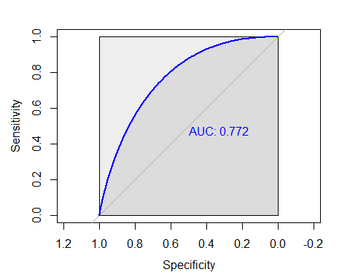 The obtained concordance index for our ROC curve is 0.772 which is much higher than random guessing. Also the goodness-of-fit is explained by the high concordance rate. Therefore, we conclude that this logistic regression model is a good predictor for the presence of brown fat.

### 6. Possible Limitations

Previously we mentioned that research shows patients with BAT will tend to have higher TSH level (Lapa C, et al. 2015). The data set records TSH, but we chose not to include TSH in the model since 90% of TSH are missing, we thus made the decision to remove the “TSH” level. Therefore, a possible strong predictor was removed due the lack of measurements of TSH.

Another possible limitation for this study is the possibility of overfitting the data. This occurs when the model that we fit perfectly follows the dataset. This would mean that the regression model perfectly encapsulates the variation between values in this data set (Javapoint). If over-fitting has occurred in this model, it would make our prediction worthless, as the model would only be useful for the known values of this particular dataset. Overfitting means the regression model has failed to pick up the relationship between predictors and the response, and memorized patterns within one dataset, making any predictions of new values untrustworthy and incorrect. A solution to this would be to create an evaluation dataset from a subsection of the original dataset, which the regression model does not train on and then compare how it performs on the two dataset.

Lastly, another limitation is the fact the model could be limited by variables in the dataset. There could be other strong predictors that model the presence of brown fat better.“Beth Israel Deaconess Medical Center (BIDMC) now indicate that brown fat can also act to regulate skeletal muscle function. … We knew that muscles could regulate brown fat – exercising increases brown fat”. (G. S, 2018) Thus, we could be measuring confounding effects of some predictors. Such as exercising can lead to decrease in LBW, and weight. Increase in muscle, muscle is dense and heavy, which increases LBW, size and weight. Since we’re not sure about the confounding effects, this is one of the major limitations to our analysis.

### 7. Conclusion

Brown adipose tissue (BAT), or brown fat, helps to regulate body temperature by generating body heat in response to cold temperatures. Through this the medical community has postulated that the activation of brown fat treatment for obesity and other metabolic diseases. After initial exploration of the dataset, we had an idea of some predictors that could be useful. We handled NA values, and then calculated the correlation matrix to see possible multicollinearity between covariates. So we can say with some confidence that Ext_Temp, 2D_Temp, 3D_Temp, 7D_Temp, 1M_Temp, Season, Duration_Of_sunshine have a significant relationship with the presence of brown fat. We fit a most complex model and using a backward elimination method, we dropped out correlated variables. Our final model, has the following significant predictors: Sex + Diabetes + Age + Ext_Temp +Two_Day_Temp + Three_Day_Temp + Weight + LBW Some of these predictors are correlated, but dropping them hurt our model. We conclude that these predictors must be very important, given the background information regarding brown fat. After multiple goodness of fit tests, Hosmer-Lemeshow, ROC Curve, etc. we are confident that this model fits the data well As mentioned in the previous slide, while we are confident in the model we do recognize the possible limitations. We conclude this study with a quote from George Box that “All models are wrong, but some are useful”

### 8. References

Check final report PDF, proper works cited included